Laplace Transforms

1 Introduction
Let f(t) be a given function which is defined for all positive values of t, if
F(s) = e^{-st} f(t) dt
exists, then F(s) is called Laplace transform of f(t) and is denoted by
L{f(t)} = F(s) = e^{-st} f(t) dt
The inverse transform, or inverse of L{f(t)} or F(s), is
f(t) = L⁻¹{F(s)}
where s is real or complex value.

[Examples]
L{1} = ; L{ e^{at} } =
L{ cos ωt } = e^{-st} cos ωt dt
=
=
(Note that s > 0, otherwise e^{-st} |diverges)
L{ sin ωt } = e^{-st} sin ωt dt (integration by parts)
= + e^{-st} cos ωt dt
= e^{-st} cos ωt dt
= L{ cos ωt } =
Note that
L{ cos ωt } = e^{-st} cos ωt dt (integration by parts)
= - e^{-st} sin ωt dt
= − L{ sin ωt }
⇒ L{ sin ωt } = L{ cos ωt } = − L{ sin ωt }
⇒ L{ sin ωt } =
L{ t^{n} } = t^{n} e^{-st} dt ( let t = z/s, dt = dz/s )
= e^{-z} = z^{n} e^{-z} dz
= ( Recall Γ(x) = e^{-t} t^{x-1} dt )
If n = 1, 2, 3, . . . Γ(n+1) = n!
⇒ L{ t^{n} } = where n is a positive integer

[Theorem]Linearity of the Laplace Transform
L{ a f(t) + b g(t) } = a L{ f(t) } + b L{ g(t) }
where a and b are constants.

[Example] L{ e^{at} } =
L{ sinh at } = ??
Since
L{ sinh at } = L
= L{ e^{at} } − L{ e^{-at} }
= =

[Example] Find L⁻¹
L⁻¹= L⁻¹
= L⁻¹+ L⁻¹
= e^{at} + e^{-at} =
= cosh at

Existence of Laplace Transforms
[Example] L{ 1/t } = ??
From the definition,
L {1/t } = dt = dt + dt
But for t in the interval 0 ≤ t ≤ 1, e^{-st} ≥ e^{-s}; if s > 0, then
dt ≥ e^{-s} + dt
However,
t⁻¹ dt = limt⁻¹ dt = limln t
= lim= lim=
⇒ dt diverges,
⇒ no Laplace Transform for 1/t !

Piecewise Continuous Functions
A function is called piecewise continuous in an interval a ≤ t ≤ b if the interval can be subdivided into a finite number of intervals in each of which the function is continuous and has finite right- and left-hand limits.
Existence Theorem
(Sufficient Conditions for Existence of Laplace Transforms) - p. 256
Let f be piecewise continuous on t 0 and satisfy the condition
| f(t) | ≤ M e^{γt}
for fixed non-negative constants γ and M, then
L{ f(t) }
exists for all s > γ.
[Proof]
Since f(t) is piecewise continuous, e^{-st} f(t) is integratable over any finite interval on t >0,
| L{ f(t) } | = ≤ e^{-st} |f(t)| dt
≤ M e^{γt} e^{-st} dt = if s > γ
⇒ L{ f(t) } exists.

[Examples] Do L{ t^{n} } , L{ e} , L{ t^{-1/2} } exist?
(i) e^{t} = 1 + t + + + . . . + + . . .
⇒ t^{n} ≤ n! e^{t}
⇒ L { t^{n} } exists.
(ii) e> M e^{γt}
⇒ L{ e} may not exist.
(iii) L{ t^{-1/2} } = , but note that t^{-1/2} → ∞ for t → 0!

2 Some Important Properties of Laplace Transforms

(1) Linearity Properties
L{ a f(t) + b g(t) } = a L{ f(t) } + b L{ g(t) }
where a and b are constants. (i.e., Laplace transform operator is linear)
(2) Laplace Transform of Derivatives
If f(t) is continuous and f'(t) is piecewise continuous for t ≥ 0, then
L { f'(t) } = s L{ f(t) } − f(0⁺)
[Proof]
L{ f'(t) } = f'(t) e^{-st} dt
Integration by parts by letting
u = e^{-st} dv = f'(t) dt
du = - s e^{-st} dt v = f(t)
⇒ L{ f'(t) } =
⇒ L { f'(t) } = s L{ f(t) } − f(0⁺)

Theorem: f(t), f'(t), . . ., f^{(n-1)}(t) are continuous functions for t ≥ 0
f^{(n)}(t) is piecewise continuous function, then
L{ f^{(n)} } = s^{n} L{ f } − s^{n-1} f(0) − s^{n-2} f'(0) − . . . − f^{(n-1)}(0)
e.g, L{ f''(t) } = s² L{ f(t) } − s f(0) − f'(0)
L{ f'''(t) } = s³ L{ f(t) } − s² f(0) − s f'(0) − f''(0)

[Example] L{ e^{at} } = ??
f(t) = e^{at}, f(0) = 1
and f'(t) = a e^{at}
⇒ L{ f'(t) } = s L{ f(t) } − f(0)
or L{ a e^{at} } = s L{ e^{at} } − 1
or a L{ e^{at} } = s L{ e^{at} } − 1
⇒ L{ e^{at} } =

[Example] L{ sin at } = ??
f(t) = sin at , f(0) = 0
f'(t) = a cos at , f'(0) = a
f''(t) = − a² sin at
Since
L{ f''(t) } = s² L{ f(t) } − s f(0) − f'(0)
⇒ L{ − a² sin at } = s² L{ sin at } − s × 0 − a
or − a² L{ sin at } = s² L{ sin at } − a
⇒ L{ sin at } =

[Example] L{ sin²t } = (Textbook, p. 259)
[Example] L{ f(t)} =L{ t sin ωt } = (Textbook)
[Example] y'' − 4 y = 0, y(0) = 1, y'(0) = 2 (IVP!)
[Solution] Take Laplace Transform on both sides,
L{ y'' − 4 y } = L{ 0 }
or L{ y'' } − 4 L{ y } = 0
s² L{ y } − s y(0) − y'(0) − 4 L{ y } = 0
or s² L{ y } − s − 2 − 4 L{ y } = 0
⇒ L{ y } = =
∴ y(t) = e^{2t}

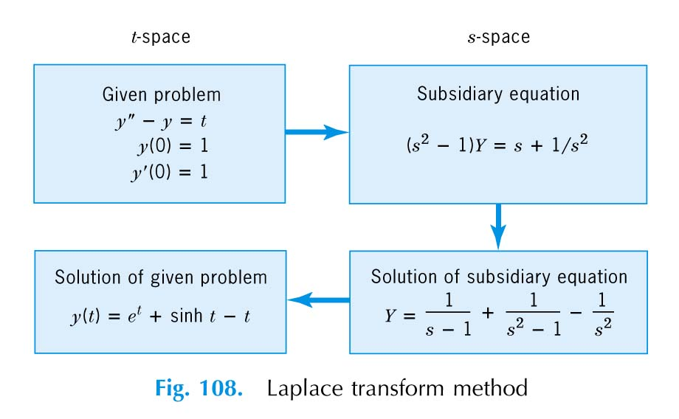

[Exercise] y'' + 4 y = 0, y(0) = 1, y'(0) = 2 (IVP!)
⇒ y(t) = cos 2t + sin 2t

[Exercise] y'' − 3 y' + 2 y = 4 t − 6, y(0) = 1, y'(0) = 3 (IVP!)
( s² Combin− s − 3 ) − 3 ( s Combin− 1 ) + 2 Combin= −
⇒ Combin= = +
∴ y = L⁻¹
= L⁻¹= e^{t} + 2 t
[Exercise] y'' − 5 y' + 4 y = e^{2t}, y(0) = 1, y'(0) = 0 (IVP!)
⇒ y(t) = − e^{2t} + e^{t} − e^{4t}

Question: Can a boundary-value problem be solved by Laplace Transform method?

[Example] y'' + 9 y = cos 2t, y(0) = 1, y(π/2) = − 1
Let y'(0) = c
∴ L{ y'' + 9 y } = L{ cos 2t }
s² Combin− s y(0) − y'(0) + 9 Combin=
or s² Combin− s − c + 9 Combin=
∴ Combin= +
= + +
⇒ y = L⁻¹{ Combin} = cos 3t + sin 3t + cos 2t
Now since y(π/2) = − 1, we have
− 1 = − c/3 − 1/5 ⇒ c = 12/5
⇒ y = cos 3t + sin 3t + cos 2t

[Exercise] Find the general solution to
y'' + 9 y = cos 2t
by Laplace Transform method.

Remarks:
Since L{ f'(t) } = s L{ f(t) } − f(0⁺) if f(t) is continuous
if f(0) = 0
⇒ L⁻¹{ s Combin} = f'(t) (i.e., multiplied by s)
[Example] If we know L⁻¹= sin t
then L⁻¹= ??
[Sol'n] Since
sin 0 = 0
⇒ L⁻¹= L⁻¹
= sin t = cos t
(3) Laplace Transform of Integrals

If f(t) is piecewise continuous and | f(t) | ≤ M e^{γt} , then
L{ } = L{ f(t) } +

[Proof]
L{ } = e^{-st} dt (integration by parts)
= + f(t) e^{-st} dt
= f(τ) dτ + f(t) e^{-st} dt
= f(τ) dτ + L{ f(t) }
Special Cases: for a = 0,
L{ f(τ) dτ } = L{ f(t) } =
Inverse:
L⁻¹= (divided by s!)

[Example] If we know L⁻¹= sin 2t
L⁻¹= ??
= sin 2τ dτ =

[Exercise] If we know L⁻¹= sin t
L⁻¹= ??
[Ans] t²/2 + cos t − 1
- Multiplication by t^{n}
( p. 275 of the Textbook )
L{ t^{n} f(t) } = (−1)^{n} = (−1)^{n} Combin
L{ t f(t) } = − Combin'(s)

[Proof]
Combin= L{ f(t) } = e^{-st} f(t) dt
= e^{-st} f(t) dt
= f(t) dt (Leibniz formula)
= − t e^{-st} f(t) dt = − t e^{-st} f(t) dt
= − L{ t f(t) }
⇒ L{ t f(t) } = − = − L{ f(t) }

[Example] L{ e^{2t} } =
L{ t e^{2t} } = - =
L{ t² e^{2t} } = =

[Exercise] L{ t sin ωt } = ??
L{ t² cos ωt } = ??

[Example] t y'' − t y' − y = 0, y(0) = 0, y'(0) = 3
[Solution]
Take the Laplace transform of both sides of the differential equation, we have
L{ t y'' − t y' − y } = L{ 0 }
or L{ t y'' } − L{ t y' } − L{ y } = 0

Since
L{ t y'' } = − L{ y'' } = −
= − s² Combin' − 2 s Combin+ y(0)
= − s² Combin' − 2 s Combin=
L{ t y' } = − L{ y' } = −
= − s Combin' − Combin=
L{ y } = Combin
⇒ − s² Combin' − 2 s Combin − s Combin' − Combin+ Combin= 0
or Combin' + = 0
Solve the above equation by separation of variable for Combin, we have
Combin=
or y = c t e^{t}
But y'(0) = 3, we have 3 = y'(0) = c (t+1) e^{t} = c
⇒ y(t) = 3 t e^{t}

[Example] Evaluate L⁻¹ indirectly by (4)
[Solution] It is easier to evaluate the inversion of the derivative of tan⁻¹ ().
( tan⁻¹s )’ =
thus, ( tan⁻¹ (1/s) )’ = = -
But L⁻¹= - sin t
and from (4) that
L⁻¹{ F’(s) } = - t f(t)
we have
-sin t = - t f(t)
⇒ f(t) =

[Example] Evaluate L⁻¹indirectly by (4)
L⁻¹= L⁻¹{ Combin} = f(t)
and Combin'(s) = = − +
Since from (4) we have
L⁻¹{ Combin'(s) } = − t f(t)
⇒ − 1 + e^{-t} = − t f(t)
∴ f(t) = ( Read p. 278 Prob. 13 - 16 )

- Division by t

L= ds
provided that exists for t → 0.

[Example] It is known that
L{ sin t } =
and lim= 1
⇒ L= = tan⁻¹ ()

[Example] (1) Determine the Laplace Transform of .
(2) In addition, evaluate the integral dt.
[Solution] (1) The Laplace Transform of sin²t can be evaluated by
L{ sin²t } = L{ } = - =
Thus, L{} = ds = ds
= [ lns - ln( s² + 4 ) ] = [ ln ]
= ln
(2) Now the integral dt can be viewed as
L{} = dt
as s = 1, thus,
dt = ln | = ln 5
(6) First Translation or Shifting Property
( s-Shifting )

If L{ f(t) } = Combin
then L{ e^{at} f(t) } = Combin
If L⁻¹{ Combin} = f(t)
⇒ L⁻¹{ Combin} = e^{at} f(t)

[Example] L{ cos 2t } =
L{ e^{-t} cos 2t } = =

[Exercise] L{ e^{-2t} sin 4t }

[Example] L⁻¹= L⁻¹
= L⁻¹
= 6 e^{2t} cos 4t + 2 e^{2t} sin 4t
= 2 e^{2t} ( 3 cos 4t + sin 4t )
(7) Second Translation or Shifting Property
( t-Shifting)
If L{ f(t) } = Combin
and g(t) =
⇒ L{ g(t) } = e^{-as} Combin

[Example] L{ t³ } = =
g(t) =
⇒ L{ g(t) } = e^{-2s}
(8) Step Functions, Impulse Functions and Periodic Functions

(a) Unit Step Function (Heaviside Function) u(t−a)
Definition:
u(t−a) =
Thus, the function
g(t) =
can be written as
g(t) = f(t−a) u(t−a)

The Laplace transform of g(t) can be calculated as
L{ f(t−a) u(t−a) } = e^{-st} f(t−a) u(t−a) dt
= e^{-st} f(t−a) dt ( by letting x = t−a )
= e^{-s(x+a)} f(x) dx
= e^{-sa} e^{-sx} f(x) dx = e^{-sa} L{ f(t) } = e^{-sa} Combin
⇒ L{ f(t−a) u(t−a) } = e^{-as} L{ f(t) } = e^{-as} Combin
and L⁻¹{ e^{-sa} Combin} = f(t−a) u(t−a)

[Example] L{ sin a(t−b) u(t−b) } = e^{-bs} L{ sin at } =

[Example] L{ u(t−a) } =

[Example] Calculate L{ f(t) }
where f(t) =
[Solution]
Since the function
u(t−2π) cos(t−2π) =
∴ the function f(t) can be written as
f(t) = e^{t} + u(t−2π) cos(t−2π)
⇒ L{ f(t) } = L{ e^{t} } + L{ u(t−2π) cos(t−2π) }
= +

[Example] L⁻¹
= L⁻¹− L⁻¹
= sin t − u( t − ) sin ( t − )
= sin t + u( t − ) cos t

[Example] Rectangular Pulse
f(t) = u(t−a) − u(t−b)
L{ f(t) } = L{ u(t−a) } − L{ u(t−b) } = −

[Example] Staircase
f(t) = u(t−a) + u(t−2a) + u(t−3a) + ...
L{ f(t) } = L{ u(t−a) } + L{ u(t−2a) }
+ L{ u(t−3a) } + ...
=
If as > 0, e^{-as} < 1 , and that
1 + x + x² + . . . = x^{n} = , | x | < 1
then, for s > 0,
L{ f(t) } =

[Example] Square Wave
f(t) = u(t) − 2 u(t−a) + 2 u(t−2a) − 2 u(t−3a) + . . .
⇒ L{ f(t) } =
= { 2 ( 1 − e^{-as} + e^{-2as} − e^{-3as} + . . . ) − 1 }
=
=
= = tanh( )

[Example] Solve for y for t > 0

with y(0) = − 5, z(0) = 6
[Solution] We take the Laplace transform of the above set of equations:

or
The solution of Combinis
Combin= = − −
⇒ y = L⁻¹{ Combin} = 2 u(t) − 4 e^{t} − 3 e^{-4t}
[Exercise]

y(0) = − 1, z(0) = 0

[Exercise] y'' + y = f(t), y(0) = y'(0) = 0
where f(t) =

(b) Unit Impulse Function ( Dirac Delta Function ) δ(t−a)

Definition: ( Fig. 117 of the Textbook )
Let f_{k}(t) =
and I_{k} = f_{k}(t) dt = 1
Define: δ(t−a) = limf_{k}(t)
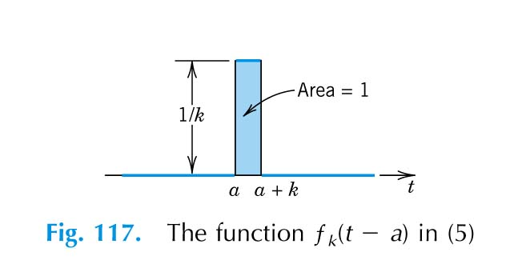

From the definition, we know
δ(t−a) =
and δ(t−a) dt = 1 δ(t−a) dt = 1

Note that
δ(t) dt = 1
δ(t) g(t) dt = g(0) for any continuous function g(t)
δ(t−a) g(t) dt = g(a)
The Laplace transform of δ(t) is
L{ δ(t−a) } = e^{-st} δ(t−a) dt = e^{-as}

[Question] L{ e^{at} cos t δ(t−3) } = ??

[Example] Find the solution of y for
y'' + 2 y' + y = δ(t−1), y(0) = 2, y'(0) = 3
[Solution]
The Laplace transform of the above equation is
( s² Combin− 2 s − 3 ) + 2 ( s Combin− 2 ) + Combin= e^{-s}
or Combin= = + +
= + +
Since
L{ t e^{-t} } = ( Recall L{ t } = )
⇒ L⁻¹= ( t − 1 ) e^{-(t - 1)} u(t − 1)
∴ y = 2 e^{-t} + 5 t e^{-t} + ( t − 1 ) e^{-(t - 1)} u(t − 1)
= e^{-t} [2 + 5 t + e ( t − 1 ) u(t − 1) ]

(c) Periodic Functions
For all t, f(t+p) = f(t), then f(t) is said to be periodic function with period p.

Theorem:
The Laplace transform of a piecewise continuous periodic function f(t) with period p is
L{ f } = e^{-st} f(t) dt
[Proof]
L{ f } = e^{-st} f(t) dt
= e^{-st} f(t) dt + e^{-st} f(t) dt
+ e^{-st} f(t) dt + . . .
But e^{-st} f(t) dt = e^{-s(u+kp)} f(u+kp) du
( where u = t − kp and 0<u<p )
= e^{-skp} e^{-su} f(u) du [ since f(u+kp) = f(u) ]
∴ L{ f } = e^{-skp} e^{-su} f(u) du
= ^{k}
=

[Example] Find L{ | sin at | }, a > 0
[Solution] p =
L{ | sin at | } =
= (Use integration by parts twice)
=
= coth()

[Example] y'' + 2 y' + 5 y= f(t), y(0) = y'(0) = 0
where f(t) = u(t) − 2 u(t−π) + 2 u(t−2π) − 2 u(t−3π) + . . .
[Solution]
The Laplace transform of the square wave f(t) is
L{ f(t) } = (derived previously)
⇒ s² Combin+ 2 s Combin+ 5 Combin=
or Combin=
Now
= =
=
and = (1 − e^{-πs}) (1 − e^{-πs} + e^{-2πs} − e^{-3πs} + . . . )
= 1 − 2 e^{-πs} + 2 e^{-2πs} − 2 e^{-3πs} + . . . (derived previously)
⇒ Combin=
The inverse Laplace transform of Combincan be calculated in the following way:
L⁻¹
L⁻¹
= u(t−kπ)
But g(t−kπ) = e^{-(t-kπ}) ( cos 2(t−kπ) + sin 2(t−kπ) )
= e^{kπ} g(t)
∴ y(t) = − u(t−π)
+ u(t−2π) - u(t−3π)
+ ……
=
−
=
− 2e^{3π}u(t−3π) + . . .) )
- Change of Scale Property

L{ f(t) } = Combin
then L{ f(at) } =
[Proof]
L{ f(at) } = e^{-st} f(at) dt = e^{-su/a} f(u) d(u/a)
= e^{-su/a} f(u) du =

[Exercise] Given that L= tan⁻¹(1/s)
Find L= ??
Note that L= = tan⁻¹(a/s)
⇒ L = a L= tan⁻¹(a/s)
(10) Laplace Transform of Convolution Integrals
- p. 279 of the Textbook

Definition
If f and g are piecewise continuous functions, then the convolution of f and g, written as (f*g), is defined by
(f*g)(t) ≡ f(t−τ) g(τ) dτ

Properties
(a) f*g = g*f (commutative law)
(f*g)(t) = f(t−τ) g(τ) dτ
= - f(v) g(t−v) dv ( by letting v = t − τ)
= g(t−v) f(v) dv = (g*f)(t) q.e.d.
(b) f*(g₁ + g₂) = f*g₁ + f*g₂ (linearity)
(c) (f*g)*v = f*(g*v)
(d) f*0 = 0*f = 0
(e) 1*f ≠ f in general

Convolution Theorem
Let Combin= L{ f(t) } and Combin= L{ g(t) }
then L{ (f*g)(t) } = Combin

[Proof]
Combin=
= e^{-s(τ+v)} f(τ) g(v) dv dτ
Let t = τ + v and consider inner integral with τ fixed, then
dt = dv and
Combin= e^{-st} f(τ) g(t−τ) dt dτ
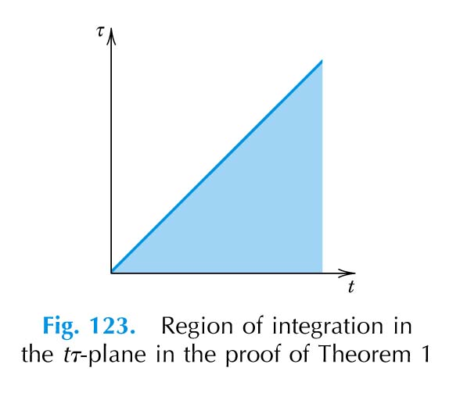
___ dt dτ = dτ dt

⇒ Combin= e^{-st} f(τ) g(t−τ) dt dτ
= e^{-st} f(τ) g(t−τ) dτ dt
= e^{-st} dt
= e^{-st} (g*f)(t) dt = e^{-st} (f*g)(t) dt
= L{ f*g }

Corollary
If Combin= L{ f(t) } and Combin= L{ g(t) }, then
L⁻¹{ Combin} = (f*g)(t)

[Example] Find L⁻¹
Recall that the Laplace transforms of cos t and sin t are
L{ cos t } = L{ sin t } =
Thus, L⁻¹
= L⁻¹
= sin t * cos t
Since sin t * cos t = sin(t−τ) cosτ dτ
= cosτ dτ
= sint cos²τ dτ − cost sinτ cosτ dτ
=

[Example] Find the solution of y to the differential equation
y'' + y = f(t), y(0) = 0, y'(0) = 1
and f(t) =
[Solution]
The function f(t) can be written in terms of unit step functions:
f(t) = u(t) − u(t−1)
Now take the Laplace transforms on both sides of the differential equation, we have
s² Combin− 1 + Combin=
or Combin= = - −
∴ y = 1 − cos t + sin t − [sint * u(t−1) ]
But the convolution sint * u(t−1) = sin(t−τ) u(τ−1) dτ
For t < 1, u(t−1) = 0, sint * u(t−1) = 0
and for t > 1, u(t−1) = 1,
sin(t−τ) u(τ−1) dτ = sin(t−τ) dτ
Thus, sint * u(t−1) = u(t−1) sin(t−τ) dτ
= u(t−1) cos(t−τ) = u(t−1) [1 − cos(t−1) ]
⇒ y = 1 − cost + sint − u(t−1) [1 − cos(t−1) ]

[Example] Volterra Integral Equation
y(t) = f(t) + g(t−τ) y(τ) dτ
where f(t) and g(t) are continuous.
The solution of y can easily be obtained by taking Laplace transforms of the above integral equation:
Combin= Combin+ Combin
⇒ Combin=
For example, to solve
y(t) = t² + sin(t−τ) y(τ) dτ
⇒ Combin= +
or Combin= +
⇒ y = t² + t⁴
(11) Limiting Values

(a) Initial-Value Theorem
limf(t) = lims Combin
(b) Final-Value Theorem
limf(t) = lims Combin

[Example] f(t) = 3 e^{-2t} , f(0) = 3 , f(∞) = 0
Combin= L{ f(t) } =
lims Combin= = 3 ⇒ f(0)
lims Combin= = 0 ⇒ f(∞)

[Exercise] Prove the above theorems

3 Partial Fractions
- Please read Sec. 5.6 of the Textbook
L⁻¹= ??
where F(s) and G(s) are polynomials in s.
Case 1 G(s) = 0 has distinct real roots
(i.e., G(s) contains unrepeated factors (s − a) )
Case 2 . . .
. . .

4 Laplace Transforms of Some Special Functions

(1) Error Function

Definition:
erf(t) = edx Error Function
erfc(t) ≡ 1 − erf(t) = edx Complementary Error Function

[Example] Find L{ erf }
erf = edx = ue ^{-u} du
( by letting u = x² )
∴ L { erf } = L
( Recall that L= L{ f(t) } )
⇒ L { erf } = L { t^{-1/2} e^{-t} }
But L{ t^{-1/2} } = =
we have L{ t^{-1/2} e^{-t} } =
⇒ L{ erf } =
[Exercise] Find L⁻¹= ??
(2) Bessel Functions

[Example] Find L{ J_{o}(t) }
Note that
[Solution]
Note that J₀(t) satisfies the Bessel's differential equation:
t J₀''(t) + J₀'(t) + t J₀(t) = 0
We now take L on both sides and note that
J₀(0) = 1 and J₀'(0) = 0
⇒ − + (s Combin − 1 ) − Combin₀' = 0
∴ = −
By separation o variable
Combin =
Note that lims Combin= f(0) (Initial Value Theorem)
lims Combin = J₀(0) = 1
we have
s = 1 ⇒ c = 1
∴ Combin = L{ J₀(t) } =

[Exercise] Find L{ t J₀(bt) } = ??
[Exercise] Find L{ J₁(t) } if J₀’(t) = - J₁(t)
[Exercise] Find L{ e^{-at} J₀(bt) }
[Exercise] Find L Hint: ds = ln ( s + )
[Exercise] Find J₀(t) dt
[Exercise] Find L{ t e^{-2t} J₁(t) }
[Exercise] Find e^{-t} dt
Summary
0 L{ 1 } = ; L{ t^{n} } = for n ∈ N
L{ e^{at} } = ; L{ sin ωt } = ; L{ cos ωt } =
1 L{ a f(t) + b g(t) } = a L{ f(t) } + b L{ g(t) }
1’ L ⁻¹{ a Combin(s) + b Combin(s) } = a L ⁻¹{ Combin(s) } + b L ⁻¹{ Combin(s) } = a f(t) + b g(t)
2 L { f’(t) } = s L{ f(t) } − f(0⁺)
Note that f(t) is continuous for t ≥ 0 and f'(t) is piecewise continuous.
2’ If f(0) = f’(0) = f’’(0) = . . . = f^{(n-1)}(0) = 0, then
L ⁻¹{ s^{n} Combin(s) } = f^{(n)}(t)
3 L{ f(τ) dτ } = L{ f(t) } =
Question: what if the integration starts from a instead of 0?
3’ L⁻¹ = . . . f(t) dt . . . dt
4 L{ t f(t) } = - Combin‘(s) ; L{ t^{n} f(t) } = ( - 1 )^{n} Combin
4’ L⁻¹ = ( - 1 )^{n} t^{n} f(t)
5 L= ds if exists for t → 0.
5’ L⁻¹=
6. L{ e^{at} f(t) } = Combin 6’ L ⁻¹{ Combin} = e^{at} f(t)
7. L{ f(t−a) u(t−a) } = e^{-as} Combin 7’ L ⁻¹{ e^{-as} Combin} = f(t−a) u(t−a)
8. L{ u(t−a) } = ; L{ δ(t−a) } = e^{-as} ;
L{ f } = e^{-st} f(t) dt where f(t) is a periodic function with period p
9. L{ f(at) } = 9’ L ⁻¹{ Combin(as) } = f()
10. L{ (f*g)(t) } = Combin 10’ L ⁻¹{ Combin} = f*g
where (f*g)(t) ≡ f(t−τ) g(τ) dτ
11. limf(t) = lims Combin ; limf(t) = lims Combin

Leibnitz's Rule: F(x,α) dx = dx + F(φ₂, α) - F(φ₁, α)

